Table of Contents

Abstract: 2

Introduction: 2

Motivation: 3

Features: 3

Components: 3

Hardware Components: 3

Software Components: 4

Tool description: 4

Arduino-Uno: 4

MQ5 Gas Sensor: 4

1k resister: 5

Buzzer: 5

LED: 6

9V Battery: 6

Jumper-Wires: 6

Bread-Board: 7

Work back-down among team member: 7

Working process: 7

Circuit-diagram: 9

Code: 10

Result: 11

Future scope: 11

Implementation image: 11

Conclusion: 11

References: 12

# Abstract:

Liquefied petroleum gas (LPG) has become a very common source of cooking fuel at home. However, LPG leakage poses a serious threat to the user and others. To avert the danger associated with the use of LPG at home, this system was developed so that gas leakage can be quickly detected and notification of the user is immediately carried out. To make the system very efficient it was configured to detect gas leakage at 2 feet and it was designed to be powered by the mains and from rechargeable battery. Test result carried out on the system was satisfactory indicating that it can be successfully deployed for domestic use.

# Introduction:

Liquefied Petroleum Gas (LPG) is a highly inflammable gas made up of the mixture of propane and butane, although butylenes, propylene and other hydrocarbons are present in small quantities .The gas is used as fuel for domestic, automobile and industrial purposes, including several heating applications. However it has gained considerable use as a cooking gas. Ethanethiol is added as a powerful odorant to give it its characteristic smell since LPG is odorless, so that when there is gas leakage it can be detected through smell. It is very important that gas leakage is detected because of the flammable nature of the gas. If left undetected it can lead to fire outbreak, causing injuries, loss of property and sometimes death. There are several factors that can lead to gas leakage such as carelessness on the part of the user, the personnel that refilled and/or service the gas cylinder/burner or faulty hose and cylinder. Although gas leakage .as a result of faulty cylinder is very rare because the cylinder can last more than two decades before it expires, it sometimes happens. To illustrate the danger of gas leakage, there was an incidence in Dhaka, Chalk bazaar where a gas explosion in an apartment in a storey building resulted in a serious injury to 71 persons who were dead on that day. This is just one of many examples showing the need for an efficient system of gas leakage detection. In this paper we developed a system that can monitor the LPG concentration in the air and simultaneously alert the user so that appropriate actions can be taken to avert the danger. A unique feature of this design is that it can also be powered by batteries so that whether there is supply from mains or not the system will be fully functional.

# Motivation:

* When the mq5 gas sensor finds LPG gas, it gives alert to the users.
* It uses LED light and buzzer for alerting the user
* User can find out the gas leakage before it’s too late.
* Every year many people of our country died from gas burns.
* Our project can save life by using it at kitchen or any stores.
* Our projects main motto is to save people from gas burns and save life.

# Features:

* Very low battery use
* 5v battery is required
* Buzzer is used to make sound
* MQ5 sensor take data and then alert users
* Light (LED) is also used to alert user
* Arduino UNO board is used to combine both hardware and software part.
* Project is very much possible with low cost.
* It can be done within a week.
* Very fast implementation process.

# Components:

## Hardware Components:

* Arduino-Uno
* MQ-5
* 2 1k resister
* Buzzer
* Led
* 9volt Battery
* Jumper-Wires
* Bread-Board
* Computer

## Software Components:

* Arduino IDE
* Windows 7

# Tool description:

## Arduino-Uno:

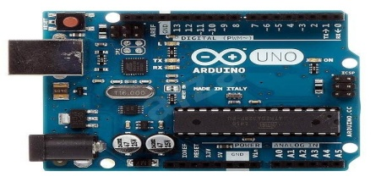

The Arduino Uno is a microcontroller board based on the ATmega328.it has 20 digital input/output pins(of which 6 can be used as PWM outputs and 6 can be used as analog inputs),a 16 MHz resonator, a USB connection, a power jack, an in-circuit system programming header, and a reset button.

## MQ5 Gas Sensor:

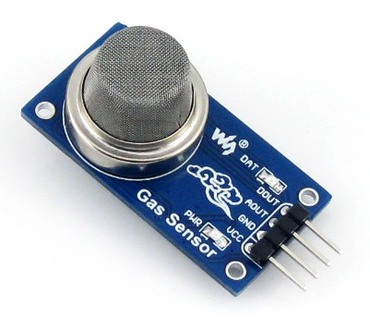

The grove-gas sensor(MQ5) module is useful for gas leakage detection. It is suitable for detecting H2,LPG,CH4,CO,ALCOHOL.due to its high sensitivity and fast response time, measurement can be taken as soon as possible.

## 1k resister:

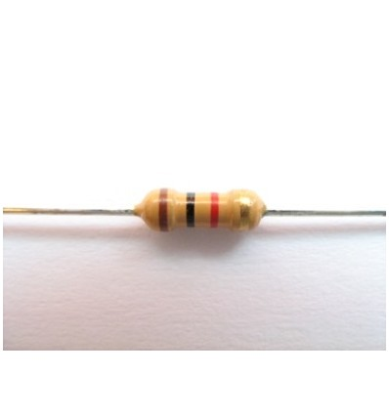

A resistor is a passive two-terminal electrical component that implements electrical resistance as a circuit element. In electronic circuits, resistors are used to reduce current flow, adjust signal levels, to divide voltages, bias active elements, and terminate transmission lines, among other uses. High-power resistors that can dissipate many watts of electrical power as heat may be used as part of motor controls, in power distribution systems, or as test loads for generators.

## Buzzer:

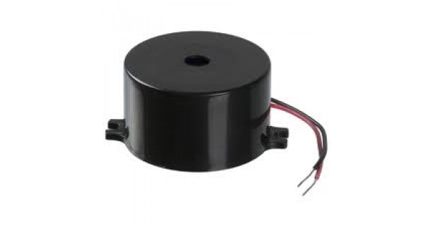

A buzzer or beeper is an audio signaling device, which maybe mechanical, electromechanical, or piezoelectric. Typical uses of buzzers and beepers include alarm devices, timers, and confirmation of user input such as a mouse click or keystroke.

## LED:



A light-emitting diode (LED) is a semiconductor light source that emits light when current flows through it. Electrons in the semiconductor recombine with electron holes, releasing energy in the form of photons.

## 9V Battery:



The 9 volt battery is a common size of battery that was introduce for the early transistor radios. It has a rectangular prism shape with rounded edges and a polarized snap connector at the top.

## Jumper-Wires:

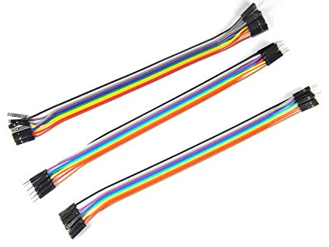

A jump wire (also known as jumper wire, or jumper) is an electrical wire, or group of them in a cable, with a connector or pin at each end (or sometimes without them – simply "tinned"), which is normally used to interconnect the components of a breadboard or other prototype or test circuit, internally or with other equipment or components, without soldering

## Bread-Board:

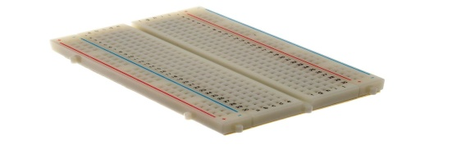

A breadboard is a construction base for prototyping of electronics. Originally it was literally a bread board, a polished piece of wood used for slicing bread citation needed In the 1970s the solder less breadboard became available and nowadays the term "breadboard" is commonly used to refer to these.

# Work back-down among team member:

|  |  |  |
| --- | --- | --- |
| **Name:** | **ID:** | **Work:** |
| 1)MD Shawon Hossain | 153402351 | Implementation ,testing and project report |
| 2)MD Faisal Ahmed | 152392326 | Coding, testing and project report |
| 3)MD Abu Bakkar | 153402348 | Financial aid and component gather |
| 4) Mehedi Hasan | 163432535 | Financial aid and component gather |
| 5)MD Riad Mia |  | Financial aid and component gather |

# Working process:

* We connect all the components together .
* Then connect the Arduino–Uno board to the computer and install the code.
* Now we take reading from our MQ5 sensor.
* If the reading data is higher than the neutral value 335,the board then triggers the buzzer and led light.
* Buzzer will make sound and led will give red light which indicates the danger signal.
* Buzzer and light won’t stop until the leakage is repaired.
* This project runs through a very small battery and at a low cost.

# Circuit-diagram:

# Code:

int buzzer = 10;

int smokeA0 = A5;

int red_light = 2;

int sensorThres = 335;

void setup() {

pinMode(buzzer, OUTPUT);

pinMode(red_light, OUTPUT);

pinMode(smokeA0, INPUT);

Serial.begin(9600);

}

void loop() {

int analogSensor = analogRead(smokeA0);

Serial.print("Pin A0: ");

Serial.println(analogSensor);

if (analogSensor > sensorThres)

{

tone(buzzer, 1000, 200);

digitalWrite(red_light, HIGH);

delay(100);

}

else

{

noTone(buzzer);

digitalWrite(red_light, LOW);}}

# Result:

Our device was able to detect the following gases H2, LPG, CH4, CO, ALCOHOL successfully and was able to give alert to the user by arising sound through buzzer and by emitting light from LED light.

# Future scope:

* We will add GSM module to our next update which will allow the user get notified through mobile message.
* We will add camera with will identify any fire arising from gas leakage and notify the fire service about it and will give the house location.

# Implementation image:

# Conclusion:

The LPG detector was developed and tested and the results were satisfactory. This is an indication that the device can be installed in home and industrial kitchen to help forestall fire incidence that result from gas leakage that goes on undetected. This device when installed will efficiently help the user to know when there is gas leakage without relying solely on the sense of smell. Since the device can be powered from the mains and a battery, reliability of the system is guaranteed all the time.

# References:

[1]B. Hossain, S. J. Shourov, M. Rana and S. Anower, "Matlab Guidance Based Smart Gas Leakage Detection and Security System Using Analog to Digital Technique," *International Journal of Smart Home, vol. 9, no. 4,* pp. 13-24, 2015.

[2]. M. J. Kesavan, R. R. Kannan, V. S. Vishwanath and P. Sathya, "LPG Gas Leakage Detection, Monitoring And Control Using LabView," *International Journal Of Innovative Research In Technology (IJIRT), vol. 1, no. 10*, pp. 151 - 155, 2014.

[3]. P. Igbonwelundu, "24 Wounded In Cooking Gas Explosion In Lagos," 10 September 2014. [Online]. Available: http://thenationonlineng.net/24-wounded-in-cooking-gas-explosion-in-lagos/. [Accessed 01 May 2017].

[4]. N. Harshada and B. Pawar, "Arm Based Gas Monitoring System," *International Journal of Scientific & Technology Research, vol. 3, no. 6,* pp. 43 - 45, June 2014.

[5]. V. Ramya and B. Palaniappan, "Embedded System for Hazardous Gas Detection and Alerting," *International Journal of Distributed and Parallel Systems (IJDPS), vol. 3, no. 3*, pp. 287-300, 2012.

[6]. B. Didpaye and S. Nanda, "Automated Unified System for LPG using Microcontroller and GSM Module," *International Journal of Advanced Research in Computer and Communication Engineering, vol. 5, no. 2,* pp. 234 - 237, February 2016.